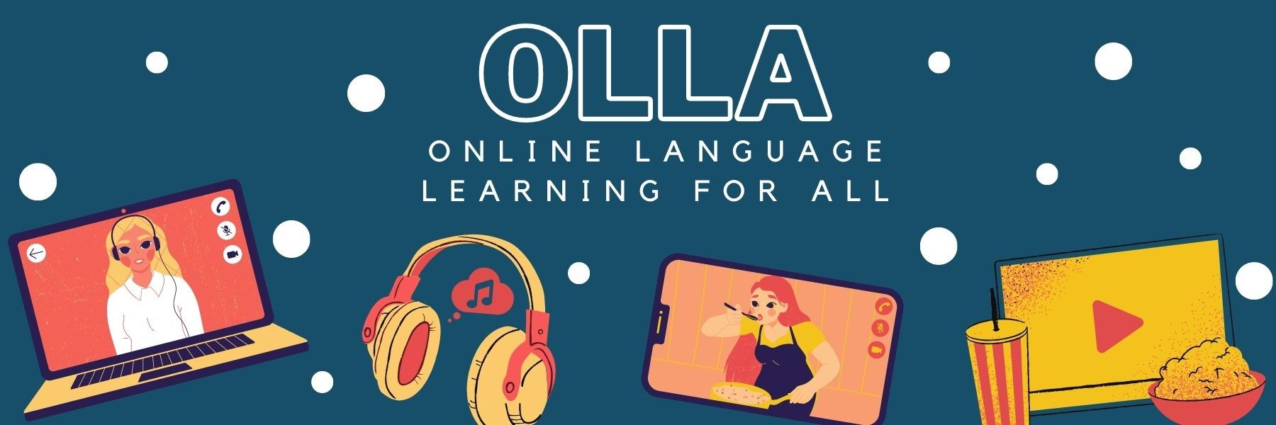

Words to know when viewing: The Most DANGEROUS Animals in the World

Jamy is a well-known TV presenter for French-speaking children. Here, he discusses the most dangerous animals in the world. Click to find out more – are they the animals you expect?

il ne faut jamais se fier aux apparences = you should never go off appearances
gabarit = dimensions
lourd = heavy
mauvaise vue = poor eyesight
comportement = behaviour
mâchoire = jaw
dents = teeth
leste = quick to anger
effrayant = scary
dépasser = exceed
aussi efficaces que celles d'un requin blanc = as efficient as a white shark’s
cavité buccale = oral cavity
morsure = bite

