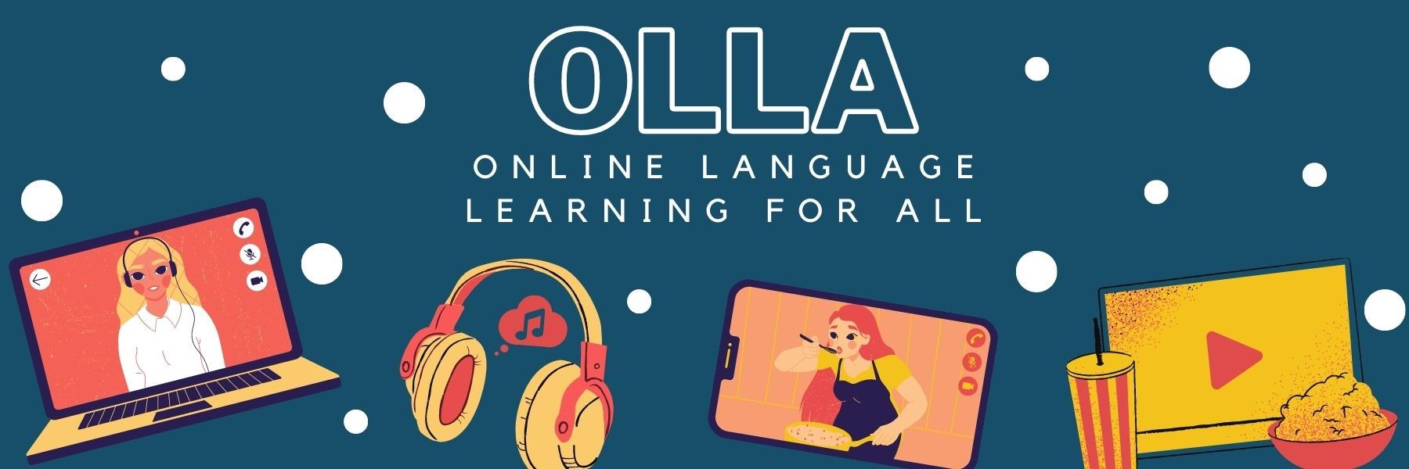

Words to know when viewing: Dossier : l'addiction aux écrans | ARTE Family

If you’re reading this, you’re looking at a screen. But when does screentime start to become a problem, and how important is it for people to be aware? Click to find out.

un écran = a screen
physicien = physicist
allumer = to light up
appareils = devices
ordinateur = computer
le cerveau = brain
on se sent mieux = we feel better
oublier tout ce qui nous entoure = to forget everything around us
corps = body
surmenés = overworked
maux = aches
le sommeil = sleep
vide = empty

