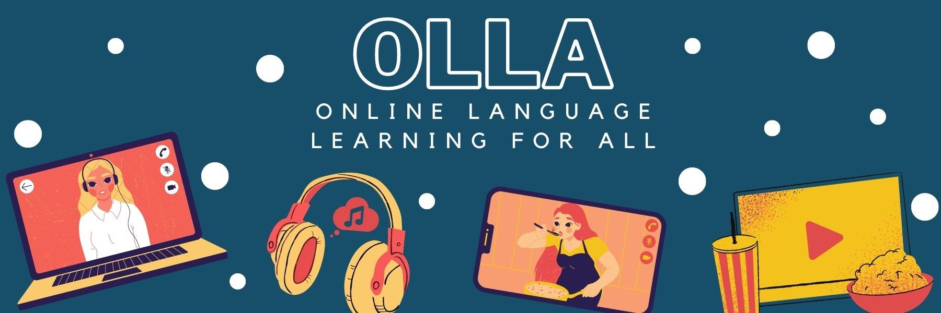

Words to know when viewing: Mickys Comic Akademie: Donald Duck

Improve your drawing skills by watching this fun tutorial on how to draw Donald Duck.

Meister = master
heute trifft er sich mit Linus = today he meets/is meeting Linus
zeichnen = to draw
Lieblingsfigur = favourite character
lustig = funny
mir gefällt = I like
Schnabel = beak
Kreis = circle
wütend = angry
Augenbrauen = eyebrows
Gesichtsausdrücke = facial expressions
unterschreiben = to sign

