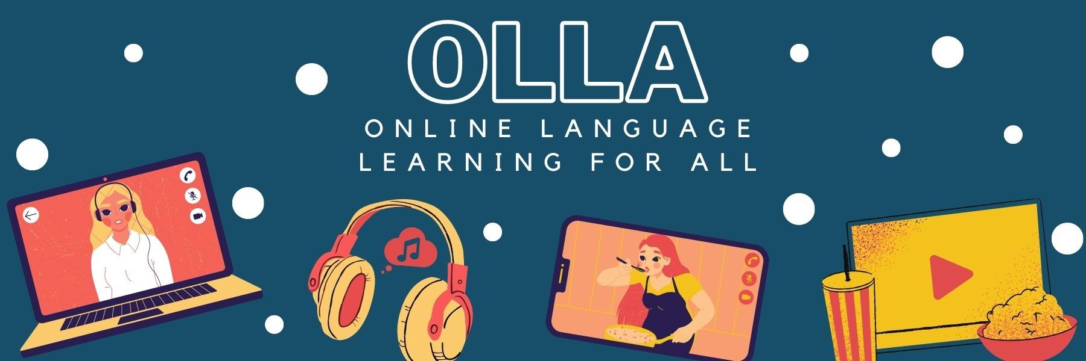

Words to know when viewing: Hip-Hop: die Dance-Challenge

Watch two friends take on a hip-hop dance challenge. Would you be able to dance a choreography after only seeing it once? Find out if Luam and Rim can!

Dunkelhäutigen = dark-skinned people
gute Laune = good mood
selbstbewusster = more confident
lässiger = more casual
probiert es euch aus = try it
bei ein Paar Tanz-Challenges mitmacht = take part in a few dance challenges
Haken = snag
wir drücken euch die Daumen = we're crossing our fingers for you
sympathisch = nice
Umarmung = hug
gastfreundlich = welcoming
dass jemand mich so beurteilt = that someone judges me like that
man sollte sich nicht so benehmen = one shouldn’t behave like that

