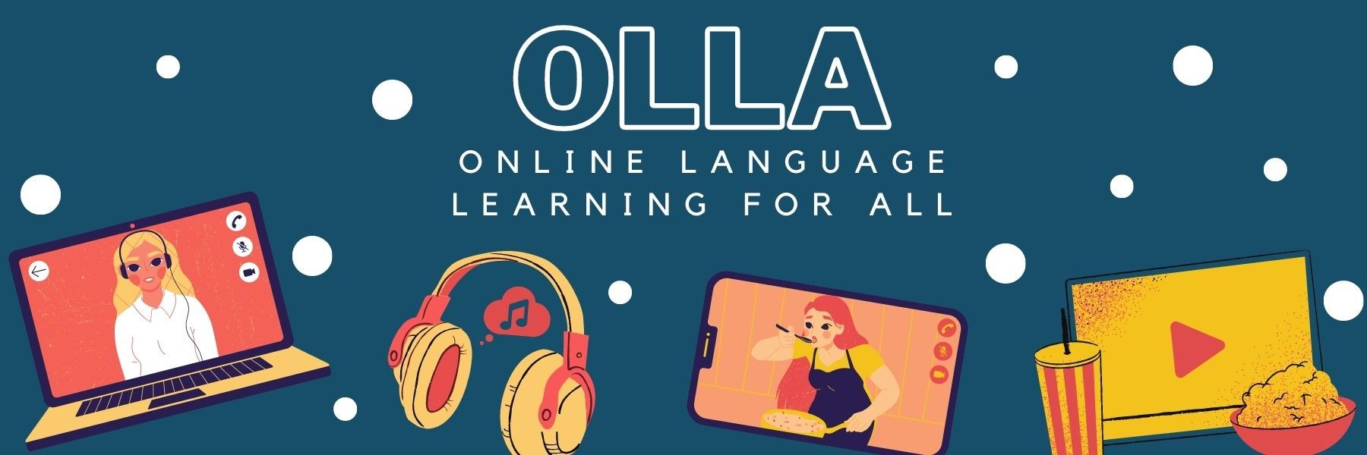

Words to know when viewing: GUTE LAUNE WORKOUT - Fitness für Kinder (ohne Equipment) - Fit für Abenteuer!

Try a fun workout to put you in a good mood and ready for adventure.

Abenteuer = adventure
gute Laune = good mood
Trikot = football shirt
Fußballweltmeister = football world champion
Regenbogen = rainbow
auf der Stelle = on the spot
Hampelmann = jumping jacks
Windmühle = windmill
einatmen/ausatmen = to breathe in/out
Daumen = thumb

